Task 2: Heart Disease Prediction Using Machine Learning

Objective
To develop a machine learning model that predicts the likelihood of heart disease based on a patient's medical information, enabling early detection and supporting clinical decision-making.

Description
Developed a predictive model using a heart disease dataset. The project involved data preprocessing, exploratory data analysis, model training, evaluation, and prediction using different machine learning algorithms.

Technologies Used
- Python
- Jupyter Notebook
- Pandas
- NumPy
- Matplotlib
- Scikit-learn

Activities Performed
- Loaded and explored the heart disease dataset.
- Cleaned and preprocessed the data.
- Performed Exploratory Data Analysis (EDA).
- Split the dataset into training and testing sets.
- Trained machine learning models:
  - Decision Tree
  - Random Forest
  - AdaBoost
- Compared model performance using accuracy scores.
- Predicted heart disease for new patient data.

Outcome
Successfully developed a heart disease prediction model capable of identifying patients at risk with good accuracy.

Skills Acquired
- Data Preprocessing
- Exploratory Data Analysis
- Decision Tree
- Random Forest
- AdaBoost
- Model Evaluation
- Disease Prediction

Output
- Displayed model accuracies.
- Compared the performance of different machine learning models.

- 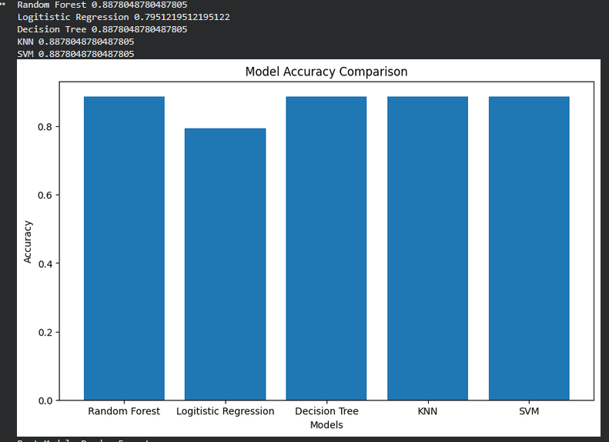
- Displayed heatmap
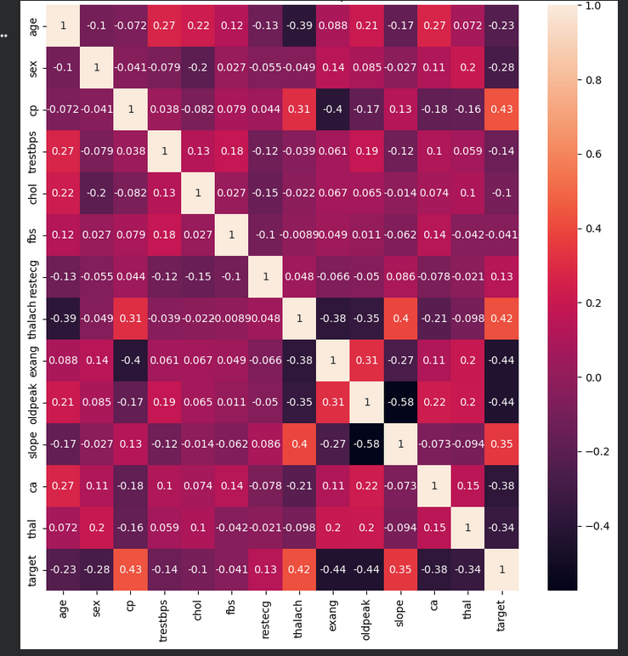
- Displayed confusion matrix
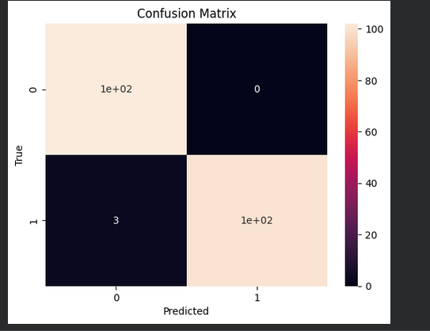
- Predicted whether a patient is likely to have heart disease based on input medical parameters.
